Accessories and modifications for ATVs

aka Pimp my ATV

# Foreword

This is designed as a beginner’s guide to accessories for Android TV boxes (ATV). If you have found this, you are likely using them for mapping in Pokémon GO.

The goal of this guide is to provide begineers with ideas for creating a safe and efficient setup that works the best it can. I have wasted money getting to the setup that I use, i.e. 20+ USB A-A cables that I won’t ever use again, would have bought USB-barrel if I was aware of them If you have an idea, feel free to submit it, so that others can benefit from your experience. Your mileage may vary.

# Powering devices

An ATV comes with a power brick you put in the outlet and then hookup up to your device. This may work for a few devices, but quickly becomes unwieldly when you increase your device count, big power strips are unbecoming. The power port on the back of your ATV is likely 5.5mm x 2.1mm barrel connector, although they may also be listed as 5.5mm x 2.5mm.

For methods not utilizing the stock brick, you will need a USB charger. There are a variety of them in amp rating, port count and features. Some have just one main switch, some have one for each port. Some have lights, some don’t. Shop around and see what is available. You will need at least 1 amp per port rating, which equals 5 watts per port. Some examples are below:

* <https://www.amazon.com/gp/product/B0773J4N43/ref=ppx_yo_dt_b_asin_title_o09_s01?ie=UTF8&psc=1>
* <https://www.amazon.com/gp/product/B07MM3CXGC/ref=ppx_yo_dt_b_asin_title_o01_s00?ie=UTF8&psc=1>

You can power your ATV through the USB port. This will require a USB A-A cable. For powering, you don’t need to worry about USB 2 or 3, just a power one, so a basic one will suffice. You will also need a USB A-A cable for flashing devices, look for higher quality data transfer ones, which should be stated in the description. An example is below:

* <https://www.amazon.com/Besgoods-2-Pack-Braided-Transfer-Player/dp/B07FCWS5QC/ref=sr_1_5?keywords=USB%2Ba-a%2Bcable&qid=1572118061&s=electronics&sr=1-5&th=1>

The cheapest way to alternatively power your ATVs is to use a USB to 5.5mm x 2.1mm. These cables cost on the order of $1.25 each. You can also buy the pigtails for the barrel connector and wire up to your own power supply. I also like this method as I use ethernet and both are right next to each other, makes things more organized. An example is below:

* <https://www.amazon.com/gp/product/B073SNC45F/ref=ppx_yo_dt_b_asin_title_o01_s00?ie=UTF8&psc=1>

An esoteric method to power devices would be to use power over ethernet (POE), but this method is cost prohibitive. You will need a POE switch and a POE active splitter for each device. Compared to standard switches, POE ones are expensive. This method would also only require one cable. Example items are listed below:

* <https://www.amazon.com/TP-Link-Compliant-Shielded-Optimization-TL-SG1005P/dp/B076HZFY3F/ref=sr_1_3?keywords=POE+switch&qid=1572117766&sr=8-3>
* <https://www.amazon.com/ethernet-Splitter-Compliant-Surveillance-ipolex/dp/B078LYW6D7/ref=sr_1_3?keywords=POE+splitter&qid=1572117894&s=electronics&sr=1-3>

# Cooling your ATV

Heat is detrimental to your devices. Some unlucky folks have had them catch on fire. Higher temperatures will cause throttling and instability, which will not help your mapping process. Although the cases have holes in them, they are not suitable for proper cooling. Approaches from passive to active have been utilized.

Passive cooling is the easiest. Simply put your ATVs on some cool tile or in the basement and let lower ambient temperatures help your situation. Got a colder room, move them to there if that is an option.

The next easiest method would be to blow air across your ATVs. Probably cheap as you may have the fan already.

Heatsinks can be utilized. Start the hunt on eBay. They could prove useful when air is forced across them. Below is an example picture of some on a x96mini:

* <https://www.amazon.com/gp/product/B01JB8MQ76/ref=ppx_yo_dt_b_asin_title_o09_s01?ie=UTF8&psc=1>

[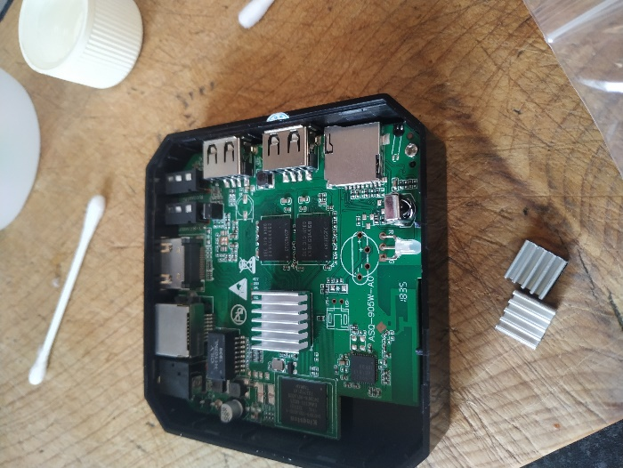](https://discordapp.com/channels/465247740553592832/590787129458688000/634687785961390110)

If you don’t mind your devices being out of the cases, you can do a setup like the following few pictures. If you need the Legos, try ebricks.com.

[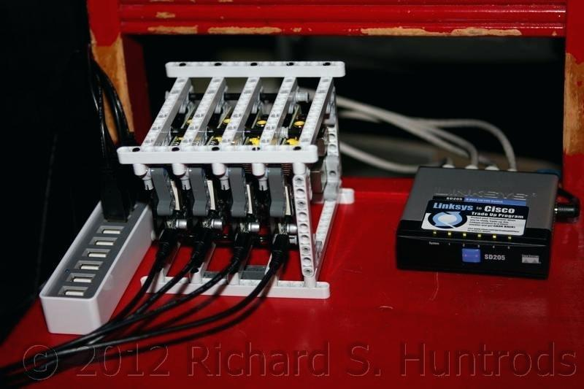](https://discordapp.com/channels/465247740553592832/590787129458688000/609514577851318492)

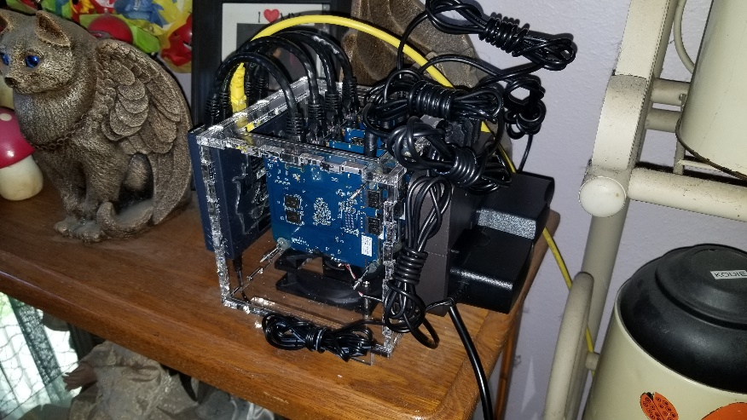

If you want to keep the board in the case you may also utilize fans. Buy a USB powered 40mm fan, disassemble the device, cut a hole with a Dremel or equivalent in the case, put it back together and attach it to the case by super glue and/or zip ties. You can setup the fan to push air into the case or pull from it, I used push configuration. I offset the fan relative to the center of the case, as there is a corner cutout on the board, as to force through as much of the case as possible. Based off their description on Amazon, they use less than 100 milliamps current. Example parts and pictures are below:

* <https://www.amazon.com/gp/product/B07JK6WGYX/ref=ppx_yo_dt_b_asin_title_o03_s01?ie=UTF8&psc=1>
* <https://www.amazon.com/gp/product/B07SQ1FQDY/ref=ppx_yo_dt_b_asin_title_o00_s00?ie=UTF8&psc=1>
* <https://www.amazon.com/dp/B071JB9WYB/ref=psdc_3015416011_t1_B07SQ1FQDY>

[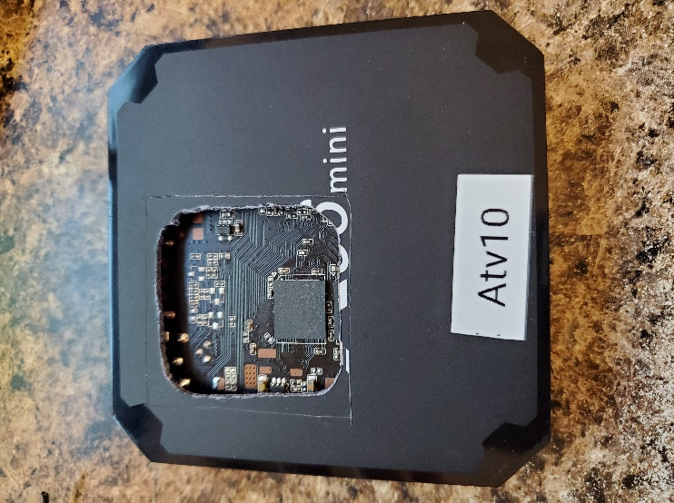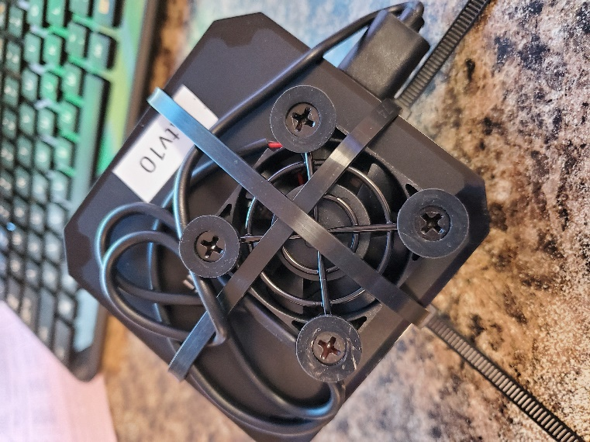](https://discordapp.com/channels/465247740553592832/590787129458688000/622717884056993803)

# Storage

Some folks have done 3D printed models for stacking devices. Browse to the following links to see a few examples:

* <https://discordapp.com/channels/465247740553592832/590787129458688000/625701792453361674>